





INITIAL
ASSESSMENT
REPORT

DATE: 11th July 2024
Compliance

VERSION: 1.2

Document History
Document version | Remarks | Submitted  By | Submission  Date | Approved BY | Approval  Date
1.0 | First Draft | k&S Digiprotect | 5th June 2024
1.1 | Second Draft | k&S Digiprotect | 4th July 2024
1.2 | Third Draft | K&S Digiprotect | 11th July 2024

Table of Contents
Introduction 4
Objectives 4
General Information 5
SPOC Information 5
Department Hierarchy* 6
Observations 7
Data Flow Diagram (DFD) 9
Data Mapping and Inventory 10
Recommendations 11
Action Plan (ISFC to share the following) 11
Conclusion 11
Appendices 12
Appendix A 12

Introduction
The Compliance Department at India Shelter Finance Corporation Limited (ISFC) is dedicated to ensuring that all departments adhere to internal policies, regulatory requirements, and industry standards. It manages compliance checklists, handles non-compliance issues, and coordinates with various departments to maintain accurate records and ensure adherence to compliance policies.
This report encapsulates critical insights for As-Is study, derived from the initial interview conducted with the Compliance Department of India Shelter Finance Corporation Limited (ISFC) for the implementation of ISO/IEC 27001:2022 and compliance with the Digital Personal Data Protection Act (DPDPA).
The overarching objectives of this interview were dual fold: first, to gain an understanding of the departmental structure, and second, to delve into the core operational processes of the Compliance Department. Additionally, the interview aimed to assess the existing information security practices, focusing on evaluating adherence to DPDPA requirements and the readiness for ISO/IEC 27001:2022 implementation.
By delving into the details of the department's organizational setup, operational workflows, and data handling procedures, this report aims to identify both the strengths and areas of improvement in information security management and DPDPA compliance within the department.

Objectives
- Understand the departmental hierarchy and reporting structure
- Learn the existing processes of ISFC’s Compliance Department
- Mapping of existing processes with documented processes
- Offer recommendations to optimize the existing processes

General Information
Organization Name | India Shelter Finance Corporation Limited
Department Name | Compliance Department
Date of the Assessment | 3rd May 2024  4th July 2024
Location | Basement, India Shelter HQ, Gurugram
Meeting Duration | 30 minutes
Attendees (ISFC) | Mukti Chaplot, Prerna Singh, Sunil Kumar Sharma
Attendees (Digiprotect) | Lalit Mohan Joshi, Adhita Razdan

SPOC Information
Project SPOC: Dheeraj Yadav
Contact Information:
Email ID: dheeraj.yadav@indiashelter.in

Project Coordinator: Sunil Kumar Sharma
Contact Information:
Email ID: sunil.sharma2@indiashelter.in

Department SPOC: Mukti Chaplot
Contact Information:
Email ID: mukti.chaplot@indiashelter.in

Department Hierarchy*

* As informed during the meeting

Observations
S. No | Key Activities | Observations and Asks | Remarks
 | Compliance Process Management  - Compliance processes are decentralized, with each department responsible for their own compliance activities.  - Compliance reports are consolidated and shared with the Board by the Compliance team on a regular basis to ensure oversight. | NA | NA
 | Compliance Monitoring and Reporting  - The Avacom compliance management system is used to automatically trigger compliance actions and notifications.  - Sampling methods are employed to check compliance across various processes, with a comprehensive checklist used for verification.  - In the last quarter, 4-5 key areas were covered  - The Head of Department (HOD) is responsible for maintaining an Excel-based checklist. These checklists are prepared and sent out by the Compliance team as per the guidelines released by regulatory authorities.  - Bank details, Aadhar Card, Pan Card, and Passport of Directors is shared with NHB. | - Avacom System has been implemented in June 2024. | - ISFC to confirm is the Avacom System is in place or it is going to be deployed soon. – Updated and recorded in Observations and Asks
 | Automation and Security Measures  - Certain compliance processes, including those related to PII and ESOPs, are automated with the HR system. | - Multi-Factor Authentication (MFA) enabled for Avacom System. | NA
 | Compliance Testing and Vendor Management  - New products undergo compliance testing as part of the development process to ensure they meet regulatory standards.  - The Compliance team collaborates with vendors and partners, with agreements covering the handling of calls, WhatsApp messages, and emails on a day-to-day basis. | NA | NA
 | Data and Document Management  - A OneDrive folder is shared with relevant stakeholders, providing view and download rights for PDFs and Excel documents containing compliance reports, financial statements, and operational data.  - Directors' passports are submitted to the National Housing Bank (NHB) for compliance purpose. | - Compliance team has limited access of Salesforce for regulatory reporting, refinance purpose and complaint handling. The view rights are pertaining to data fields which are necessary for data reporting. | - ISFC to explain business case for giving compliance team entire salesforce view access. – Updated and recorded in Observations and Asks  - The Treasury team also has access to these passports and shares them with the National Housing Bank (NHB) for compliance purposes. (for information purpose only. No action required)

Data Flow Diagram (DFD)
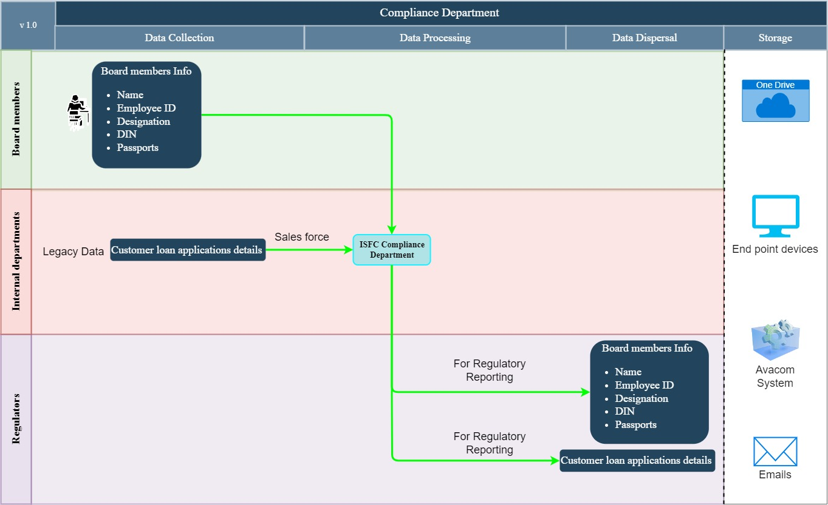

Data Mapping and Inventory
S. No | Data Category | Description | Purpose | Data Owner | Storage Location | Data Classification* | Retention Period | Legal Basis
1 | Compliance Reports | Compliance reports consolidated and shared with the Board | Ensure oversight | Compliance Department | Avacom system/ Emails/ Physical documents | Non PII/ Confidential | Not Defined | Regulatory Compliance
2 | Compliance Certificates | Detailed certificates for all compliances prepared by HOD | Company-wide compliance documentation | Compliance Department | Avacom System/  Emails/ OneDrive | Non PII/ Confidential | Not Defined | Regulatory Compliance
3 | Compliance Actions and Notifications | Automatically triggered compliance actions and notifications | Ensure timely compliance actions | Compliance Department | Avacom system | Non PII/ Confidential | Not Defined | Regulatory Compliance
4 | Compliance Checklists | Sampling methods and comprehensive checklists for verification | Check compliance across processes | Head of Department (HOD) | Excel / OneDrive/ Emails | Non PII/ Confidential | Not Defined | Regulatory Compliance
5 | Directors' Passports | Passports of Directors submitted to NHB for compliance purposes | Meet regulatory requirements | Compliance Department | NHB portal/ One Drive | PII/ Sensitive | Not Defined | Regulatory Requirement
*Refer Appendix A

Recommendations
- Continuous Compliance Testing
  - Integrate continuous compliance testing into the development lifecycle of new products and services.
  - Document and review test results to identify and address potential compliance issues promptly

Action Plan (ISFC to share the following)
- Detailed Certificate used for Compliances sent to departments. - Shared
- Policies and procedure documents - Shared
- Copy of Agreements with Vendors - Shared

Conclusion
The compliance department of ISFC plays a critical role in ensuring the institution operates legally, ethically, and responsibly. By effectively managing compliance risks, the department safeguards the ISFC from financial penalties, reputational damage, and regulatory sanctions.
Compliance processes are decentralized, with each department responsible for their own compliance activities. Detailed certificates for all compliances are prepared by the Head of Department and are included in a company-wide compliance calendar. Compliance reports are consolidated and shared with the Board on a regular basis to ensure oversight. From September 2024, the Compliance reports and certificates will be maintained on the Avacom System.
Compliance Monitoring and Reporting is maintained through:
- Avacom system- A compliance management system that automatically trigger compliance actions and notifications.
- Sampling methods - Maintaining compliance across various processes, with a comprehensive checklist used for verification.
- Board's Monitoring and Advisory Committee.
- Excel-based checklists that includes action items for regulatory compliance for compliance testing.
Policies are reviewed and updated on a quarterly basis. Compliance documentations are updated on a need basis. New products and services undergo compliance testing as part of the development process to ensure they meet regulatory standards.
Vendor and partner compliance is monitored, with agreements handling the covering of:
  - calls,
  - WhatsApp messages,
  - Emails on a day-to-day basis
Director's passports are submitted to the National Housing Bank (NHB) for compliance purpose.

Appendices

Appendix A
Data Classification | Definition
Sensitive Data | Information that, if disclosed, altered, or destroyed without authorization, could cause significant harm to an individual, organization, or entity. This often includes financial records, medical information, and PII.
Restricted Data | Highly sensitive data tightly controlled due to legal, regulatory, or contractual requirements. Access is limited to authorized personnel, and any unauthorized disclosure may result in severe consequences.
Private Data | Information considered confidential and intended solely for specific individuals or groups within an organization. It requires protection from unauthorized access to maintain privacy and uphold confidentiality agreements.
Confidential Data | Privileged or proprietary information of an organization requiring protection from unauthorized access, disclosure, or alteration.
Public Data | Information that is freely available and accessible to the general public without restrictions or limitations. It does not contain sensitive or confidential information and can be openly accessed and used for various purposes such as research, analysis, and public interest initiatives.
PII (Personally Identifiable Information) | Data that can identify, contact, or locate an individual, either alone or in combination with other information. For example - names, addresses, official identifiers (Aadhar, Pan, DL, biometrics, etc).
Non-PII | Data that, while not personally identifiable, however may still require protection due to its sensitivity or confidentiality. This may include corporate financial information, proprietary research data, or internal communications.

---------------------------------------End of report for Compliance------------------------------

